HO CHI MINH CITY UNIVERSITY OF TECHNOLOGY

FACULTY OF COMPUTER SCIENCE AND ENGINEERING

COURSE: COMPUTER NETWORK

LAB 3a: UDP

Supervisor : Nguyễn Hồng Nam.

Author : Nguyễn Quang Long.

ID : 1812917.

Saturday, October 24th , 2020

1. Select one UDP packet from your trace. From this packet, determine how many fields there are in the UDP header. (You shouldn’t look in the textbook! Answer these questions directly from what you observe in the packet trace.) Name these fields.

* 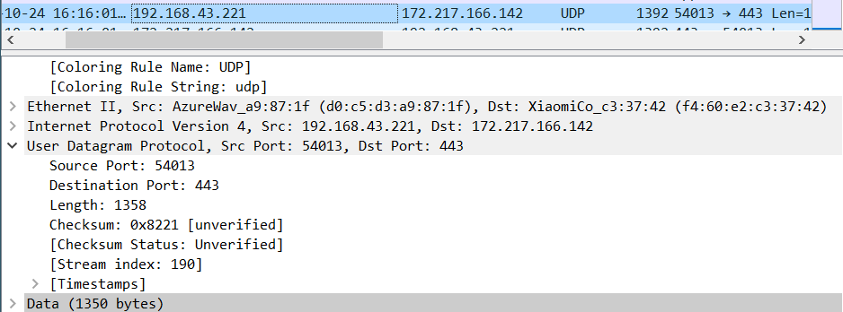**Answer**: Source port, Destination Port, Length, Checksum.

Figure

1. By consulting the displayed information in Wireshark’s packet content field for this packet, determine the length (in bytes) of each of the UDP header fields.

* **Answer** : the length of the UDP header fields is 2bytes (16 bits). If you take a look at the Checksum field in figure 1, it has the value of 0x8221 which represents 16 bits.

1. The value in the Length field is the length of what? (You can consult the text for this answer). Verify your claim with your captured UDP packet.

* **Answer :** The length field specifies the length of the UDP segment, including the header, in bytes. We can verify it with the example show in figure 1. The length of Data (1350 bytes) + 4 header = 1350 + 4*2 = 1358 bytes.

1. What is the maximum number of bytes that can be included in a UDP payload? (Hint: the answer to this question can be determined by your answer to 2. above)

* **Answer :** Each header is 2 bytes length so the maximum value of length would be 65535 – 8 = 65527 bytes.

1. What is the largest possible source port number? (Hint: see the hint in 4.)

* **Answer :** it would be 2 power 16. 216 = 655356

1. What is the protocol number for UDP? Give your answer in both hexadecimal and decimal notation. To answer this question, you’ll need to look into the Protocol field of the IP datagram containing this UDP segment (see Figure 4.13 in the text, and the discussion of IP header fields).

* **Answer :** it’s 17 in decimal and 0x11 in heximal (figure 2).

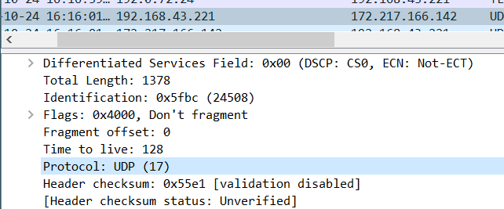

Figure 2

1. Examine a pair of UDP packets in which your host sends the first UDP packet and the second UDP packet is a reply to this first UDP packet. (Hint: for a second packet to be sent in response to a first packet, the sender of the first packet should be the destination of the second packet). Describe the relationship between the port numbers in the two packets.

* **Answer :** the destination port of the packet which my host sent is 443, which also be the source port of the reply packet. Similar, the source port of the packet which my host sent is 54013, which also be the destination port of the reply packet.



